Read two numbers and perform all arithmetic operations [ +, -, *, %, / ].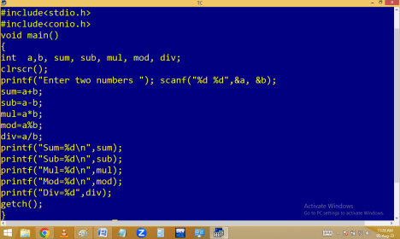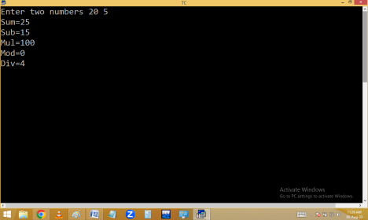
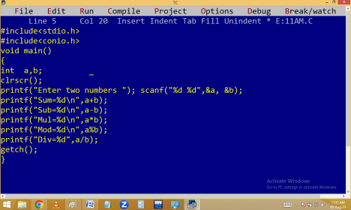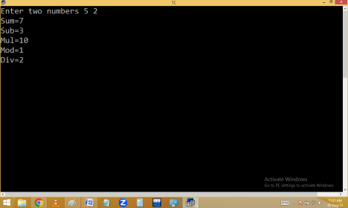
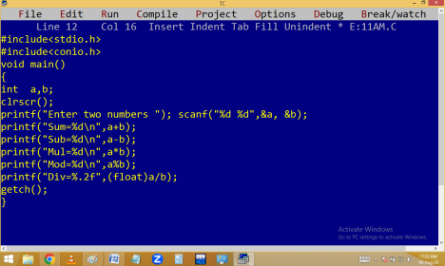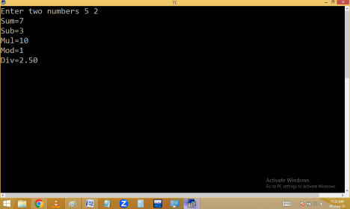
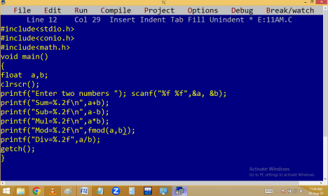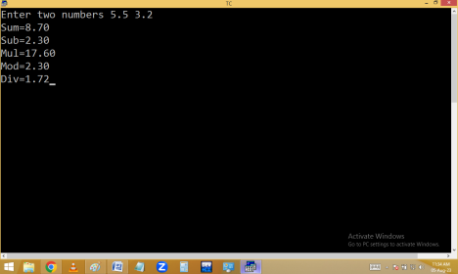
Read a baby age in no of days and find the baby age in years, months, weeks and days.
500 days baby age is 1 year 4 months 2 weeks and 1 day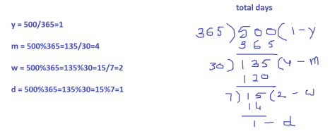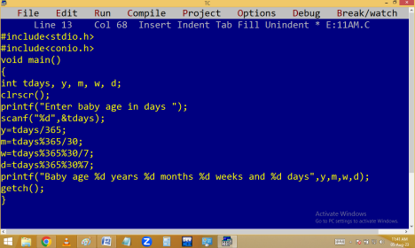
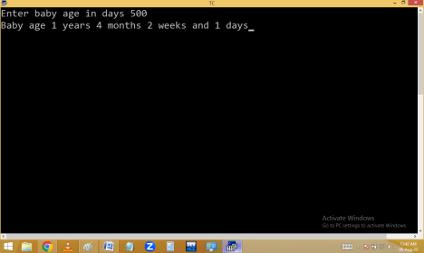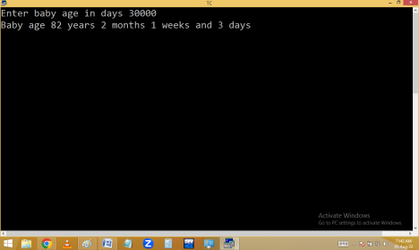
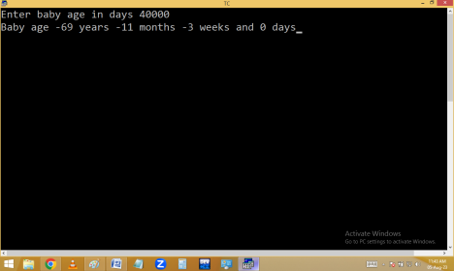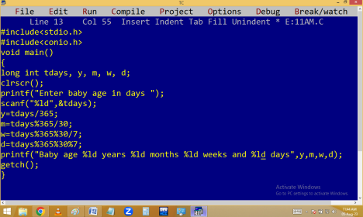
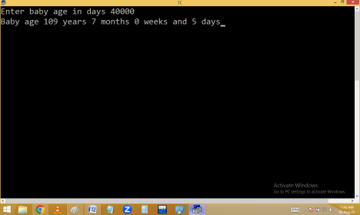
Read baby age in years, months, weeks and days. Find the baby age in days.
Read a customer id, name, Quantity purchased and rate of item. Find amount, 35% discount and net bill.
CONTROL STATEMENTS / CONTROL STRUCTURES
They are used to control program execution order. In c we are using the following control statements.
goto label / jumping statement
It is used to transfer program execution from one place to another place [label].
In this process it is jumping from one area to another without any condition. Hence it is also called unconditional jumping statement.
Syntax:
Here goto is a keyword.
Label is an identifier is used to identify the area[line].
Every label should be end with : (colon)
Keywords not allowed in labels i.e. label should be user defined.
Duplicate labels not allowed.
There is no space between go and to.
Label naming rules are similar to the identifier rules.
Note: goto label working style is similar to loops some times.

